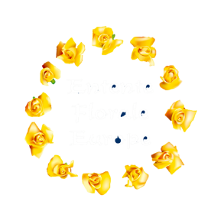 

**12/06/22**

**A Message from the President and Jury Chair,**

**Entente Florale Europe.**

**Dear Participants,**

**After a break of two years, the on-site assessments for the 2022 Entente Florale Europe competition are now underway, and we are aware that you are now engaged in preparations and final touches for the visits of our International Jury teams.**

**On behalf of the AEFP board and our teams of mentors, we are well aware of the demands that entering the competition has made on you during this difficult time. We are very pleased and proud that you have made so much of an effort to present your community for the upcoming Jury visits.**

**Due to the Pandemic, the last two years have been very challenging for you all and it is indeed a great achievement to have prepared your settlement so well for the competition.**

**We are looking forward to meeting you all over the coming weeks during our visits and experiencing the hospitality and welcome, which is very much part of the Entente Florale Europe family.**

**Our world can seem so uncertain and volatile during these times, but your strong community spirit can be relied upon as a source of great hope and positivity for the future. We are looking forward to meeting you all together with your very committed citizens at the Prize Giving Ceremony on the 24.09.22, in Balatonfüred, Hungary. You will receive more details on this event in the near future.**

**Keep up the good work!**

**Wishing you all the best of luck,**

|  |  |  |
| --- | --- | --- |
| **………………………………** | **……………………………….** |  |
| **Dr Rüdiger Paul Kirsten** | **Dr Christy Boylan** |  |
| **President A.E.F.P.** | **Chair of the Jury** |  |