Entente Florale Europe Results 2022
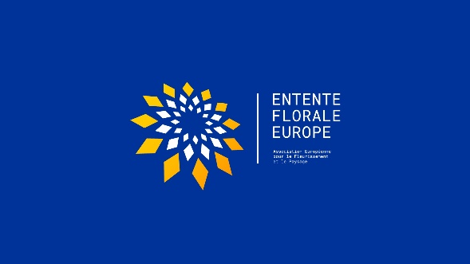

-------------------------------------------------------
24/09/22
The Official Results of the Entente Florale Competition for 2022 have been announced.
At an Awards Ceremony held in the Hungarian city of Balatonfüred on the 24/09/22, the official results of the Entente Florale Europe Competition for 2022 were announced. The following were the results;
- Bad Sauerbrunn - Austria – Gold Medal
- Bollstedt - Germany – Silver Medal
- Orfü - Hungary – Gold Medal
- Dalkey - Ireland - Silver Medal
- Diksmuide - Belgium – Gold Medal
- Veresegyház - Hungary – Silver Medal
- Dobrochov – Czech Republic – Gold Medal
- Keadue - Ireland – Gold Medal
- Székesfehérvár – Hungary – Gold Medal

Also announced at the ceremony were a number of Special Characteristic Prizes which were as follows.

- Bad Sauerbrunn, Austria – Special Characteristic Prize for Hugelland Park. A playground consisting of several hills of different heights and shapes and divided into different play zones. It was made with natural materials, mainly acacia wood and larch. Any form of plastic was avoided.
- Bollstedt, Germany – Special Characteristic Prize for the Landscape Conservation Club. The outstanding commitment of the Landscape Conservation Club to developing wildflower meadows, planting shrubs and the ‘Riedgarten’ project.
- Orfü, Hungary – Special Characteristic Prize for the Ecotourism Visitor Centre. The centre for environmental education at the Bear Garlic House. This is an interactive exhibition which is presented in a playful way and offers green tours and programmes.
- Dalkey, Ireland – Special Characteristic Prize for the conservation strategy for Dalkey Island. The outstanding conservation of Dalkey Island and work of Dalkey Tidy Towns Committee and especially their unique Energy Plan.
- Diksmuide, Belgium – Special Characteristic Prize for the Rainwater and Drought Action Plan.
- Veresegyház, Hungary – Special Characteristic Prize for the care of the Green Spaces.
- Dobrochov, Czech Republic – Special Characteristic Prize for the Biocentre. A three-hectare area of land with three small ponds connected to a natural corridor for the movement of wildlife. It also serves as a natural shelter for game.
- Keadue, Ireland – Special Characteristic Prize for the maintenance of the Heritage Park. The special approach of the Heritage Park maintenance, including the integration of wildlife meadows, especially the orchids.
- Székesfehérvár, Hungary – Special Characteristic Prize for the care of its trees. Generally, the care of the trees, especially the plane tree in the square multi-functionality of the public parks.

A number of Thematic Prizes were also announced on the night as follows,

- Herbert Titz Memorial Prize 2022 – Prize winner Diksmuide. For the community garden, their work and approach
- President’s Prize – Prize winner Veresegyház for the unique environmentally friendly Geothermal Heating System.
- EFE World Urban Parks Green Spaces Award – Prize winner Székesfehérvár. The highest (average) score achieved for the criterion ‘Green Spaces’.
In his speech at the Awards Ceremony, the President of AEFP Dr. Rüdiger Paul Kirsten, thanked all the cities, towns and villages for their continued commitment to the competition. He acknowledged that it had been very difficult for them to participate in the competition, during the period of the Pandemic.
He went on to say that all the cities, towns and villages who entered the competition in 2022 are considered to be a shining example of how to work for the sustainability of settlements and will be a reference point for other Towns and villages across Europe, into the future. He confirmed that he was extremely satisfied with the engagement of all their citizens, when it came to the green policies and their implementation and in his view healthy, green settlements are the key to a prosperous future.

-------------------------------------------------------

Participants 2022
- Bad Sauerbrunn - Austria
Bad Sauerbrunn is a village in the county of Burgenland, located in the southeast of Austria, close to the border with Hungary. This traditional spa town with about 2,300 inhabitants is the health center of the northern part of Burgenland.
More than 125.000 overnight stays confirm Bad Sauerbrunn as a modern tourist destination, but also it is a popular residential area because of the beautiful surroundings.
During their stay the jury were impressed by the diverse Parks and green areas full of biodiversity and perennial plantings, also by the high standard of maintenance and the tree care program. The participation of the inhabitants and the environmental education of young and old is important in Bad Sauerbrunn. A perfect example of that is the Hügelland-Park, built by volunteers and full of Biodiversity, a joy to explore and learn about.
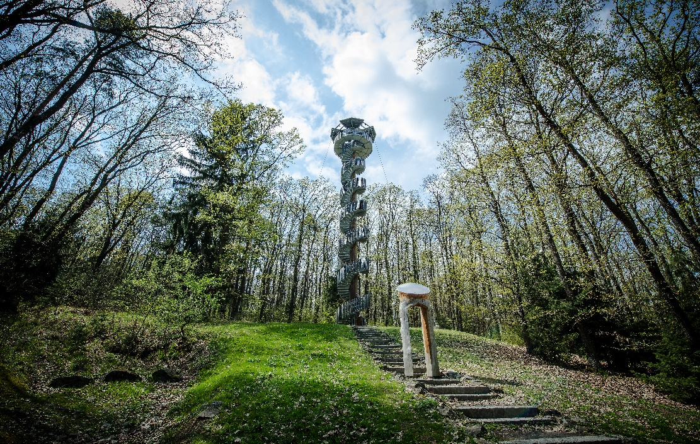

- Bollstedt - Germany.
Bollstedt is a small Village located in middle of Germany. The Village forms part of the beautiful town area of Mühlhausen in the State Thuringia. The 1,013 inhabitants were very proud to show the Jury all they have achieved in recent years and how their community working together, has developed the village sustainably to create a future which is worth living in.
The Village community was inspired by the Competition, completed over a number of stages, called „Our Village has a future “. Bollstedt is a location which exemplifies the best elements of the Smart City strategy.
The Jury enjoyed very much the Riedgarten Project, which was implemented by the very active locally-based Landscape Conservation Association. There you can find a wide range of Biotopes, from Cottage gardens through to Meadow Orchards, Willow planting belts and hedge planting. Bollstedt is a Village with a really great future.

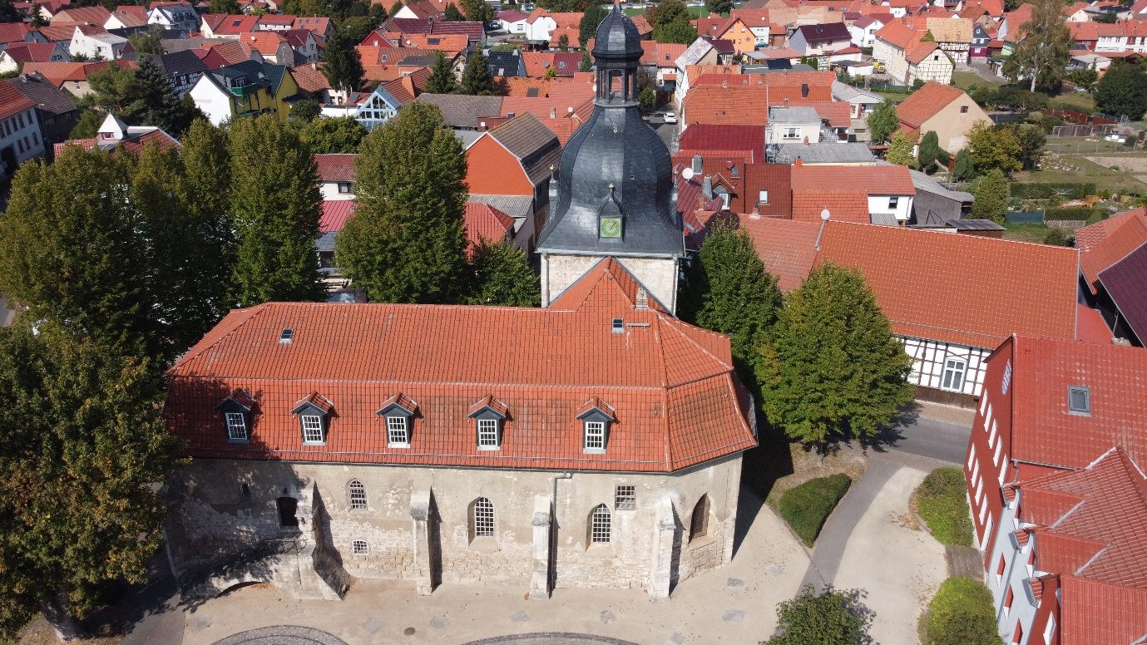

- Orfü - Hungary.
Orfű is a village in the Mecsek Mountains, formed by the merger of five smaller villages. Its defining character, apart from the mountain forests, is the system of artificial lakes created in the 1960s on the Orfű stream and the recreational uses - water sports and hiking - that have developed since then. In addition to the stunning scenery, Orfű's growing popularity is also due to its efforts to preserve the quality of its environment, its high quality cultural and sports programmes and the cohesion of the local community. There is a strong focus on the preservation and presentation of the built and natural heritage, with the internationally renowned architecture and programmes at the Mefvehla House and the mills attracting many visitors. It is one of the strongholds of quality tourism in Hungary.

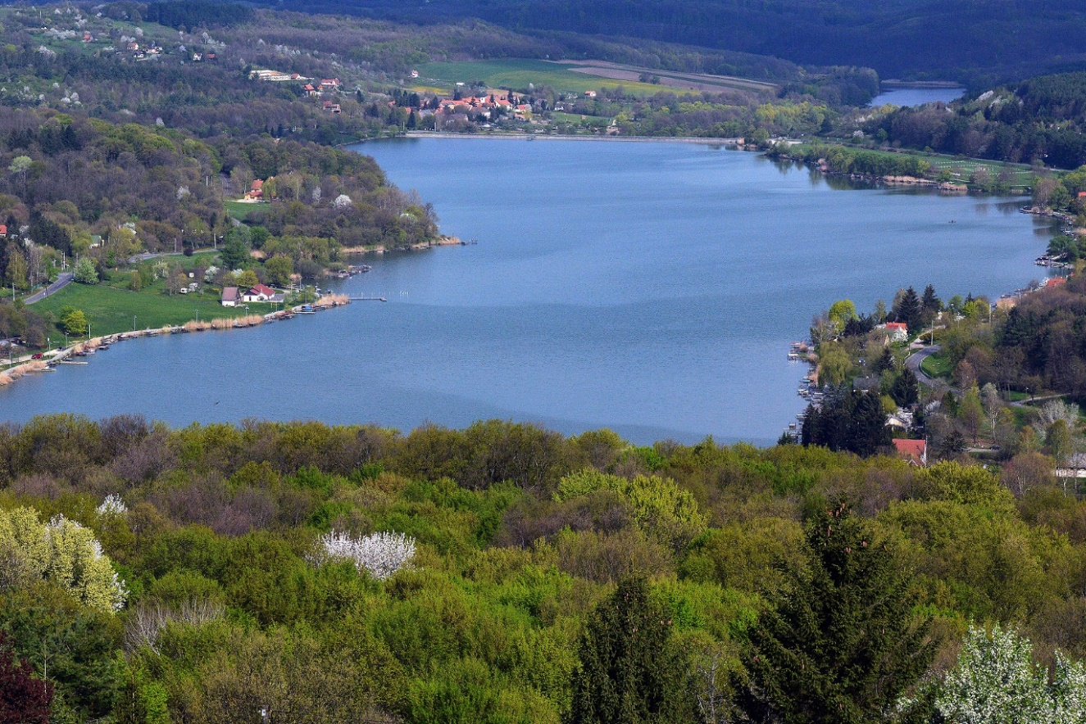

- Dalkey - Ireland.
Dalkey is a popular coastal town with a population of almost 7,000 residents. Situated in the east of County Dublin it is a ‘a town with a village atmosphere’. The town is located between the Dublin Mountains and Dublin Bay. Its medieval evidence is obvious to all who visit and features remains of seven Medieval buildings. It is Dalkey’s first time to enter the Entente Florale Competition and has been a high scorer in Ireland’s National Tidy Towns Competition for many years. It lays great emphasis on current and long-term projects and is a firm believer in cooperation and volunteerism. Its great distinction is Dalkey Island which is accessible and offers a combination of natural and manmade attractions. This is a managed landscape and is unique in its location. Education within the town is well served and has six schools participating in Green programmes, laying emphasis on Nature and Biodiversity. Its local harbour, which forms part of the town provides boating facilities for locals and visitors. The local Dart Rail service is of huge importance to Dalkey and the surrounding area, facilitating commuter traffic from far and near. For business and pleasure Dalkey is first class and the hand of friendship is warm and genuine, do make a visit.
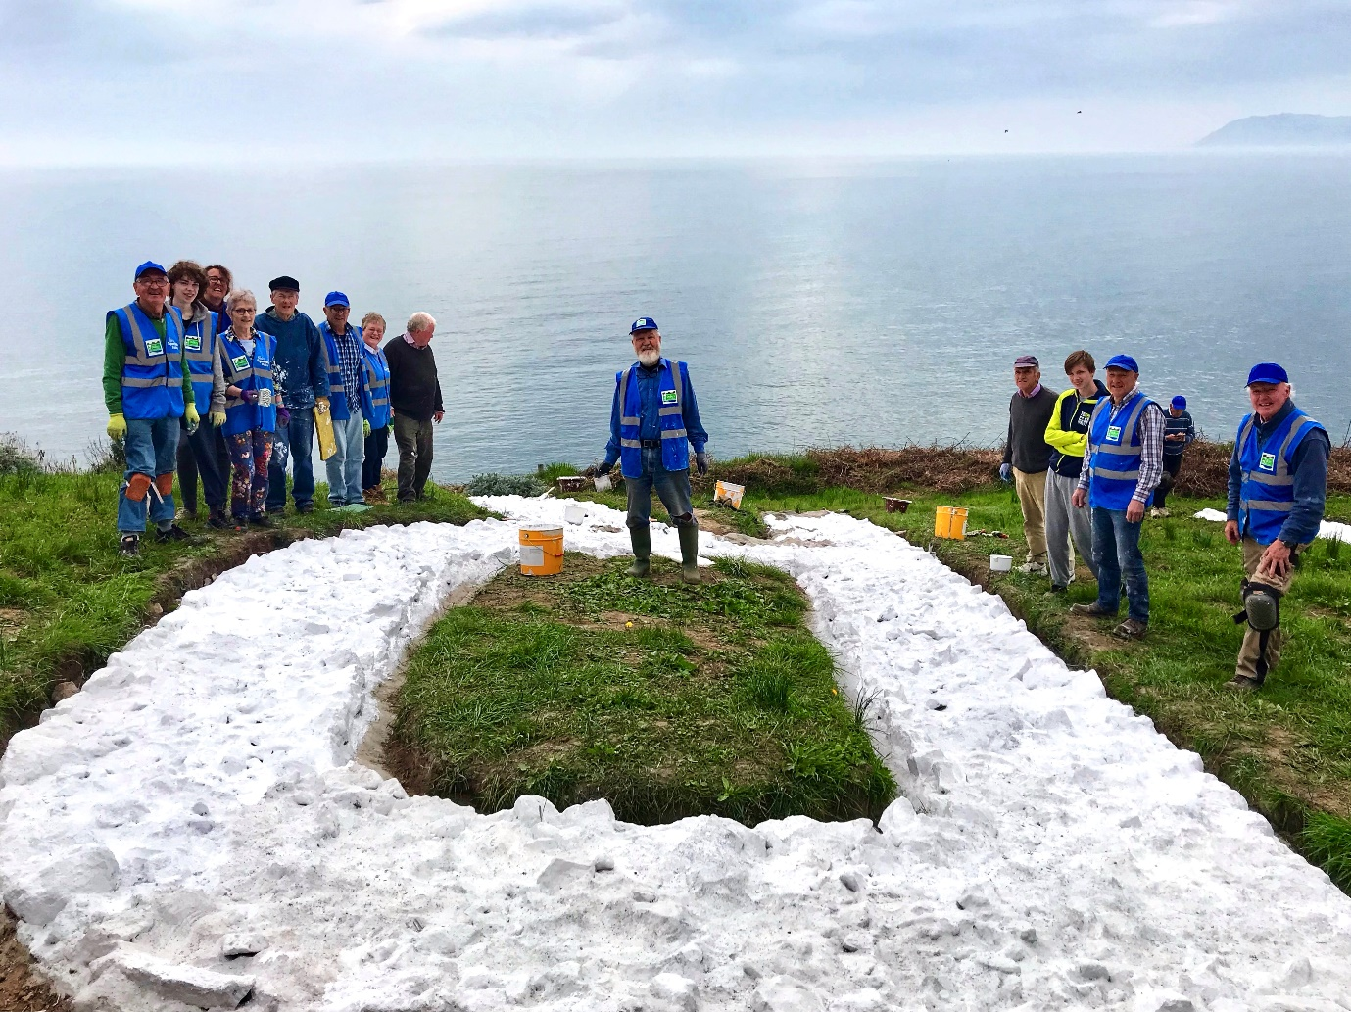

- Diksmuide - Belgium.
Diksmuide is located in the west of Belgium at 15 km from the North Sea coast. During the First World War it was an important military site and became a target with total destruction as a result. The memories of the war remain visible in the landscape. Nowadays Diksmuide lays in a ‘Green Sea ’with a strong focus on tourism and outdoor recreation. Highlights are the beautiful scenery, panoramic views, small villages and protected nature reserves with most important habitats for numerous bird species. With its extensive rural expanse including 15 villages, the town represents a great deal in terms of maintenance and layout of the landscape where biodiversity, sustainability, heritage and citizen participation are ever present and are a constant focus for local inhabitants.

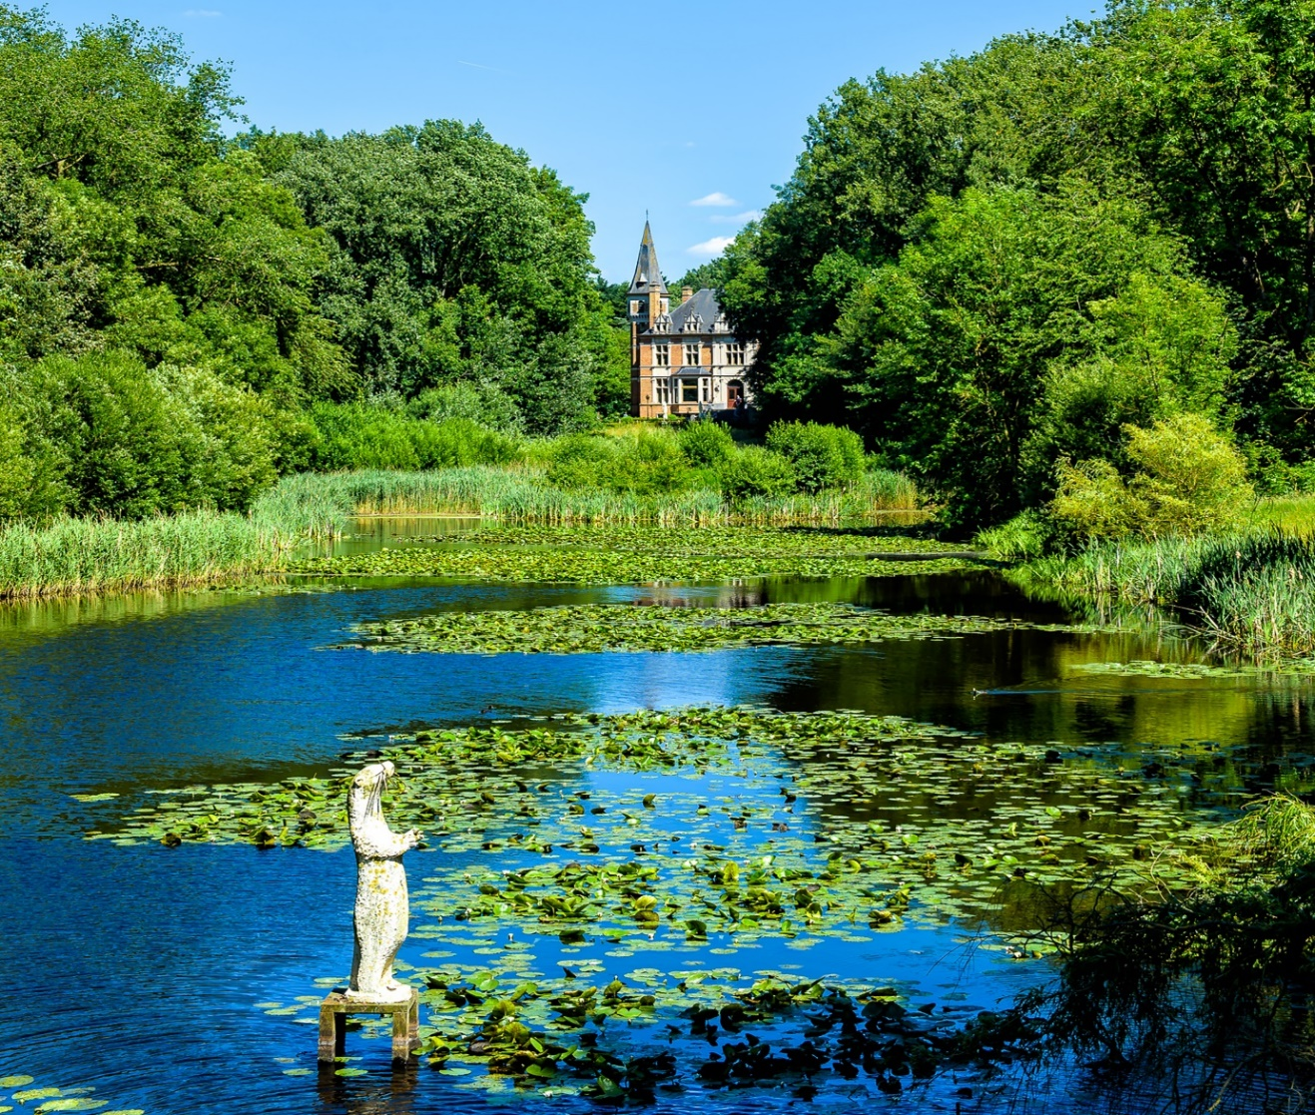

- Veresegyház - Hungary.
Veresegyház is one of the young towns of the Budapest agglomeration, which thanks to our conscious and careful urban development is now attractive to both industrialists and residents. Developing neighbourhoods along the valley of the Sződ-Rákos stream, along the lakes and the surrounding hills, with a high proportion of green areas, make the town a lively one. The high architectural quality and the uniform appearance of the public buildings and spaces are a defining feature. The high quality of green space maintenance and planting is unique. A particular highlight is the operation of the city's own network of thermal springs, which are used to heat not only public buildings but also industrial plants and residential buildings.
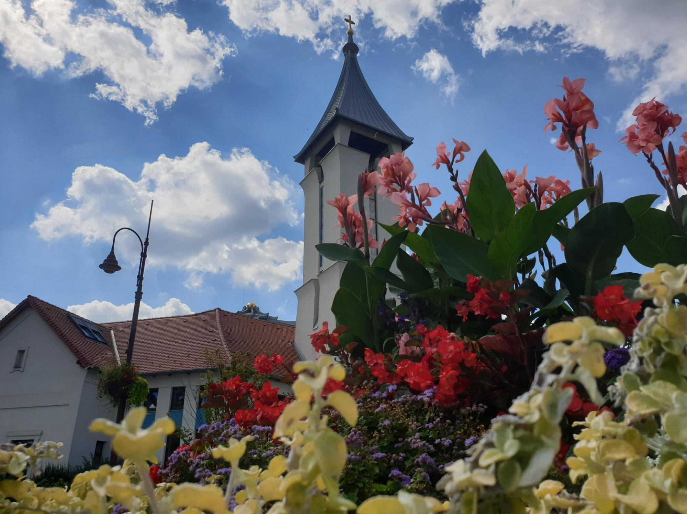

- Dobrochov – Czech Republic.
Dobrochov is a beautiful rural village in the central part of Moravia, in the Haná region, near the county town Olomouc. Currently it has 356 inhabitants living on an area of 252 hectares.
After the fall of communism in 1989, the desire of the inhabitants to manage their public affairs independently were fulfilled and independence was achieved. Since then, the pace of development has accelerated and there has been an active community life among the residents.
Dobrochov has preserved the rural character of a Moravian agricultural village, with its own tradition and rich cultural and social life. The main development topic is investment in green structures in the agricultural landscape and in the village itself.

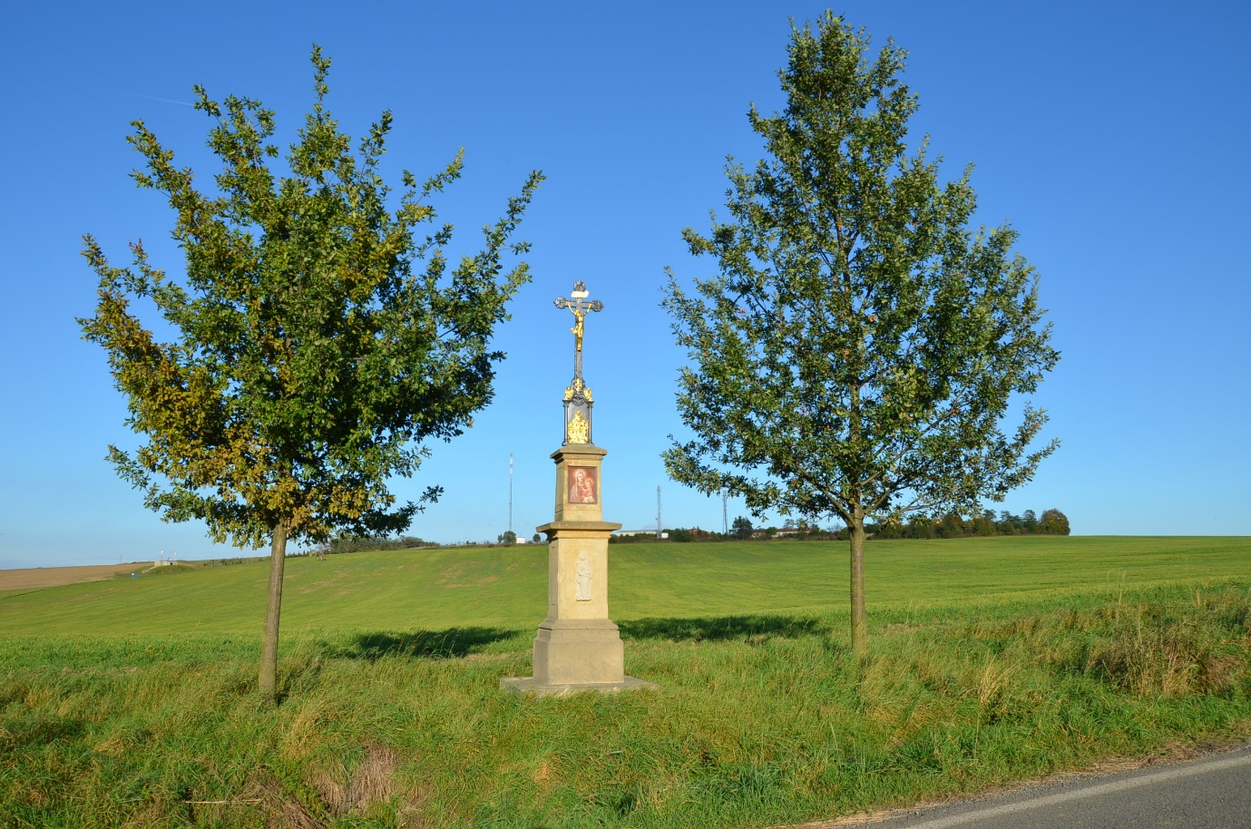

- Keadue - Ireland.
Keadue is a small rural village of 145 residents and is part of Ireland’s Hidden Heartland. Situated near the shores of Lough Meelagh in the parish of Kilronan, it has a long successful association with Ireland’s National Tidy Towns Competition
and was an outright winner of the competition in 1993 and 2003. In 2004 and 2005 it won the Best Kept Village Award in Ireland. Twenty years ago, Keadue won a silver medal in the Entente Florale Competition. Its greatest strength lies in the area of cooperation and regional development. The wide range of sporting activities available provides opportunities for all age groups both indoor and outdoor and enables participants to enjoy facilities in all weather conditions. The beautiful lake adjacent to the village offers opportunities for water activity and is further enhanced by the adjoining Knockranny Wood that offers a variety of walks. The community of Keadue benefits significantly from its close association with Roscommon County Council and developments are well discussed in advance of works commencing. Visitors are always welcome to Keadue and Tourism accommodation is of a high standard, offering a variety of facilities. Make a visit and be rewarded, you will be welcome.

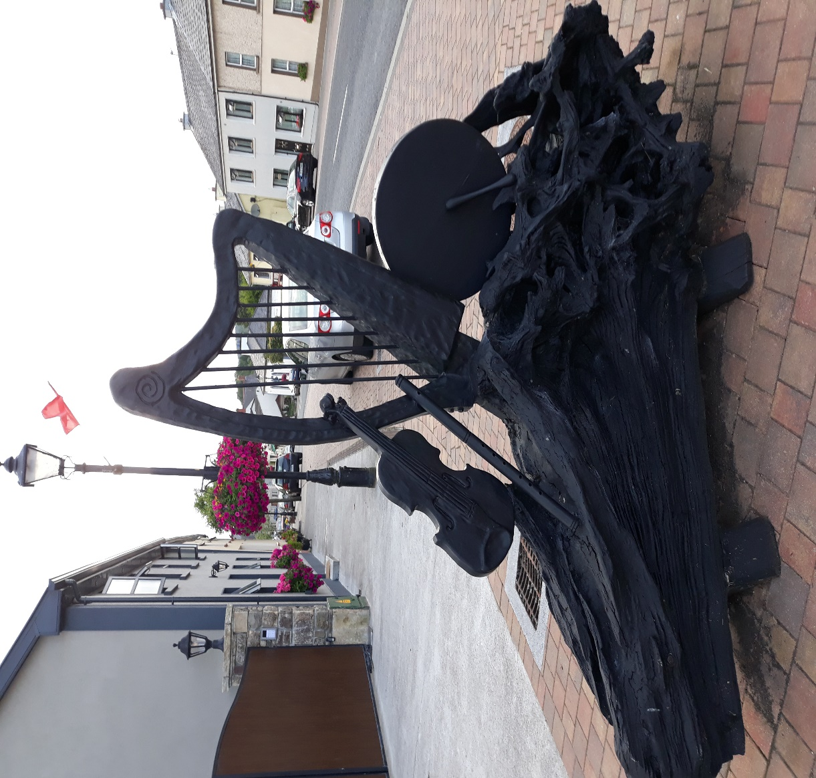

- Székesfehérvár – Hungary.

Székesfehérvár, a city with county rights in Transdanubia, is the centre of the Central Transdanubia region, one of the largest and most important cities in Hungary. The industrial city of the 21st century has a rich built and natural heritage, which it manages with great skill. The buildings and public spaces of the historic city centre are being regenerated in line with modern open space architecture and sustainability principles, making the city attractive and liveable. The Sóstó nature reserve and education centre is a unique asset for the city. The high proportion of green space and the significant tree cover successfully compensate for the environmental pressures of the city. A special mention should be made of the green roof programme for the social integration of homeless people.

