Association Européenne pour le Fleurissement et le Paysage / aisbl (A.E,F.P.)

Secretary General  William Kearney  6 Coolamber Park,Knocklyon,  Dublin 16, Dublin, Ireland,D16Y1F7.  phone: 00353871007633  mail: info@entente-florale.eu  web : www.entente-florale.eu | Entente Florale Europe  President’s Prize 2024 | 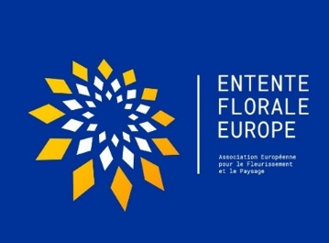

President`s Prize – Climate Change Mitigation.
In recent times there has been much debate about climate change and how increased levels of
gases such as Carbon Dioxide are causing global temperatures to rise. This is leading to higher
sea levels and extremes of weather patterns, resulting in more frequent storms, followed by severe
flooding. This is happening at a time when there is a global movement of people to urban areas
where they have less contact with natural areas such as forests and parks and are more
dependent on fossil fuels for heating and transport.
Climate change will have serious impacts for urban areas. In coming decades, building resilience
will be essential urban policy and a smart investment. And while many are beginning to build
resilience in response to emerging threats associated with climate change, the strategies they are
adopting are often win-win results, making them healthier, more attractive places to live and do
business. Resilience is brandable and demonstrates a willingness to embrace innovation culture.
Innovative Nature Based Solutions are socially equitable and user-friendly adaptation measures
that support the reduction of summer heat load on people in buildings and open spaces. Urban
green infrastructure is essential to the design of natural and appropriately configured open spaces
and to secure ecosystem services for us humans to promote biodiversity and increase the quality of
life and the immediate living environment. Each entrant to the 2022 Entente Florale Europe
competition is invited to submit a project for consideration by the visiting jury for this award.

Suitable projects may include:
• A conservation area/ecosystem within the community and in which they play an important role
in its protection.
• A landscape/green area where the management system is focused on sustainability and multi-
functionality of the ecosystem, for example, forests and recreation or farms with educational
facilities including biodiversity. This may also include wetland areas.
• Measures termed “Greening the Grey”. Examples include green roofs, green walls, tree
planting in streets or car parks, rain gardens etc. and restoration of degraded/polluted/derelict
areas within the community.
Criteria:
Each entry will be judged by the adjudicators during their visit to the community. They will be
examining the achievements/effects of the project in terms of quality and quantity as follows:
- Result/ benefits of project realization
- involvement of the community, partners, scientists
- influence of the project on the aspects of climate change
- standard of design, construction and maintenance
- best practice example
How to present the nomination:
- A short submission of max one A4 page with the main facts of the project should be submitted separately but accompanying the participant’s Portfolio and should be lodged on or before on the 1st of June.

