Secretary General  Bill Kearney, 6 Coolamber Park,  Knocklyon, Dublin D16‌ ‌Y1F7  Tel: ‌ 00353871007633‌ ‌  email: ‌info@entente-florale.eu‌  Website:‌ ‌‌www.entente-florale.eu‌  Facebook: follow us on Facebook | Association‌ ‌Europeenne‌ ‌pour‌ ‌le‌ ‌Fleurissement‌ ‌et‌ ‌le‌ ‌Paysage‌ ‌/‌ ‌aisbl‌ ‌  Entente‌ ‌Florale‌ ‌Europe‌ ‌  ‌Jubilee Year Entry ‌Form‌ ‌2025‌ | 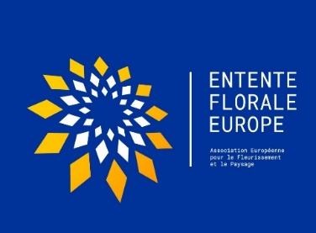  ‌
Entry‌ ‌Form‌ ‌2025. ‌Page 1. | ‌ | ‌ ‌
‌
‌I‌ ‌wish‌ ‌to‌ ‌nominate; ‌‌
‌
‌---------------------------------------------------------------- ‌ ‌
Name‌ ‌of‌ City/ ‌Town/Village‌ ‌ ‌
as‌ ‌a‌ ‌candidate‌ ‌in‌ ‌Entente‌ ‌Florale‌ ‌Europe‌ ‌competition‌ ‌in‌ ‌2025 in the category.
City ________‌ ‌ ‌ Town_________ Village_________ X (tick the relevant category).
‌
Official Declaration: Competition Rules and Regulations.
I‌ ‌declare‌ ‌that‌ ‌I‌ ‌am‌ ‌aware‌ of ‌and will fully comply with ‌the‌ ‌regulations‌ ‌and‌ ‌guidelines‌ ‌governing‌ ‌this‌ ‌awards scheme in 2025, (available at ‌‌www.entente-florale.eu‌). We will fully accept and respect the result of the EFE awards scheme.

Signed on behalf of the Participant: …………………………………………………….

Position: ……………………………………………. Date: …………………….

Contact Details:
 | City, ‌Town or‌ ‌Village‌ ‌  ‌ |  | ‌ ‌  ‌
 | Country‌  ‌ |  | ‌ ‌ | ‌ ‌ Population: ‌ |  | ‌
 | Mailing‌ ‌address‌ ‌of‌ ‌the‌ ‌Town‌ ‌Hall‌ or Administrative Office.‌ ‌
Telephone‌ ‌number‌ ‌
‌
 | E-mail‌ ‌Address  ‌ |  | ‌
 | Website‌ ‌ ‌
 | ‌Mayor/Chairperson/Chief Executive Officer.‌ ‌ ‌ |  | ‌ ‌
 | Details of contact person ‌ |  | Name:  ‌ ‌ ‌  Phone: ‌  ‌ ‌  E-mail: ‌
‌‌Secretary General  Bill Kearney, 6 Coolamber Park,  Knocklyon, Dublin D16‌ ‌Y1F7  Tel: ‌ 00353871007633‌ ‌  email: ‌info@entente-florale.eu  Website :‌ ‌‌www.entente-florale.eu‌ ‌ |  | Association‌ ‌Europeenne‌ ‌pour‌ ‌le‌ ‌Fleurissement‌ ‌et‌ ‌le‌ ‌Paysage‌ ‌/‌ ‌aisbl‌ ‌  Entente‌ ‌Florale‌ ‌Europe‌ ‌  ‌Jubilee Year Entry ‌Form‌ ‌2025‌ ‌ |  |  | 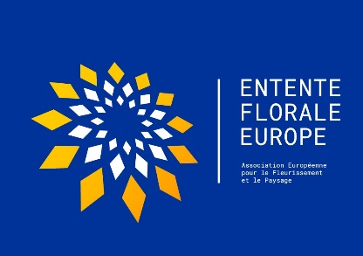
Entry‌ ‌Form‌ ‌2025‌ ‌. Page 2. |  | ‌ |  |  | ‌

Please provide a short‌ ‌description of ‌the‌ ‌city/town‌ /‌ ‌village‌ ‌–‌ ‌(maximum‌ ‌150‌ ‌words)‌ ‌-‌ ‌having regard to ‌the‌ ‌EFE Assessment‌ ‌Criteria.‌ ‌We will publish this information ‌on‌ ‌the‌ ‌AEFP‌ ‌webpage‌ ‌‌www.entente-florale.eu‌‌ ‌and‌ ‌on our‌ ‌Facebook‌ ‌site.‌ ‌
‌
Description:

Please specify‌ ‌your ‌preferred 14‌ ‌days‌ ‌period,‌ (between the dates from 25 June to the 31st of July 2025) during which ‌you wish the EFE ‌jury‌ ‌panel‌ ‌to ‌visit‌ ‌your‌ ‌community. ‌ ‌ ‌ | ‌  Between Dates: ‌........................ and .................................
N. B. Note:
- Every effort will be made to accommodate your preferred dates, but if ‌there‌ ‌is‌ ‌no‌ ‌other‌ ‌option available, ‌ ‌the‌ ‌jury‌ ‌visit‌ ‌may‌ ‌have to be ‌outside‌ ‌of‌ your designated ‌time‌ ‌period.
- For‌ ‌organizational ‌reasons,‌ ‌two‌ ‌entrants‌ ‌from‌ ‌the‌ ‌same‌ ‌country‌ ‌should‌ ‌choose‌ ‌the‌ ‌same time‌ ‌period.‌ ‌Please‌ mention if there are any ‌national‌ ‌holidays‌ ‌during‌ ‌this‌ ‌period – please see below.
Secretary General  Bill Kearney, 6 Coolamber Park,  Knocklyon, Dublin D16‌ ‌Y17F  Tel: ‌ 00353871007633‌ ‌  email: ‌info@entente-florale.eu‌  Internet :‌ ‌‌www.entente-florale.eu‌ | Association‌ ‌Europeenne‌ ‌pour‌ ‌le‌ ‌Fleurissement‌ ‌et‌ ‌le‌ ‌Paysage‌ ‌/‌ ‌aisbl‌ ‌  Entente‌ ‌Florale‌ ‌Europe‌ ‌  ‌Jubilee Year Entry ‌Form‌ ‌2025 | 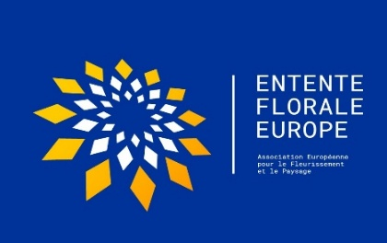  ‌
Entry‌ ‌Form‌ ‌2025‌. Page 3. | ‌ | ‌

Further Details:  National Holiday(s) date(s)‌ ‌:‌ …………………………………………………….  ‌  ………………………………………………………………………………………‌ ‌ ‌  Name of Mayor/Chief Executive/Nominated Councillor (Typed):‌ ‌  ...................................................................................................‌ ‌  Signature of Mayor‌ ‌/‌Chief Executive‌ ‌/‌ ‌Nominated Councillor‌. | Official ‌Seal‌  ‌ ‌‌
Country Details:
Name of the National Competition (if any): ..................................................................

Name of the National Co-ordinator (if any): ..................................................................

‌Name(s) of Mentor(s) (if any) to assist with your
participation in the awards scheme: ………………………………………………………………………………
For‌ ‌the Entente Florale Europe Homepage,‌ Facebook‌, Instagram ‌and‌ ‌other‌ ‌marketing‌ ‌options,‌ ‌please‌ ‌send‌ ‌;

1.0 -‌ This‌ ‌Form‌ duly completed ‌in‌ ‌both‌ Word ‌‌and‌ ‌pdf ‌formats ‌plus, ‌ ‌
2.0 –‌ ‌A total of 10‌ ‌good quality and representative ‌jpeg‌ ‌photos‌‌ ‌- highlighting the main features of your City/Town/ Village, as‌ ‌separate‌ ‌files‌ ‌ (‌name‌ ‌them‌ ‌after‌ ‌your‌ ‌town‌ ‌or‌ ‌village‌ ‌for‌ ‌example):‌ ‌
Paris1.jpg‌...‌ ‌etc.‌ ‌‌),‌ ‌

to‌ ‌‌info@entente-florale.eu‌‌
‌on or before‌ ‌the‌ ‌15‌^{th‌‌} ‌of‌ ‌January 2025. ‌

