Secretary General  William Kearney  6 Coolamber Park, Knocklyon, Dublin 16, Dublin, Ireland,D16Y1F7.  phone: 00353871007633  mail: info@entente-florale.eu  web : www.entente-florale.eu | Entente Florale Europe  Results 2025 | 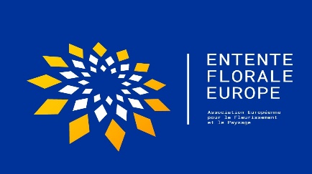
 | Page 1 of 2

Entente Florale Europe Results and Awards 2025
This year the jury awarded 6 silver and 5 gold medals, and all participants can take pride in their communities’ achievements.
Category | Participant | Country | Award
Village | Babylon | Czech  Republic | Gold
City | Nice | France | Gold
Village | Terryglass | Ireland | Gold
Town | Maynooth | Ireland | Gold
Village | Huglfing | Germany | Gold
Village | Zedtwitz | Germany | Silver
Town | Costigliole d’Asti | Italy | Silver
City | Nantes | France | Silver
City | Satu Mare | Romania | Silver
Village | Varsány | Hungary | Silver
City | Nyíregyháza | Hungary | Silver

The jury also awarded the following special awards:
Award | Project | Participant
President’s Prize | The ‘Retrofit Demonstration House’ | Maynooth, Ireland
Herbert Titz Memorial Prize | The ‘Mandala Herb garden’ at the castle. | Zedwitz, Germany
Green Space Award – with World Urban Parks | The highest (average) score for the criterion ‘Green Spaces’ | Nyiregyháza, Hungary  Nantes, France
50th Jubilee Special Jury Prize | For the special environmental education programmes at the local school | Costigliole d’Asti, Italy

Special Characteristics Outstanding activities or features)

Satu Mare, Romania | For the excellent digital survey of trees in the city that was started in 2017 and has been updated several times since then
Nyíregyháza, Hungary | For the impressive squares and green spaces in the city centre which have been pedestrianized and expanded.
Varsány, Hungary | For the sensitive approach being taken to improving tourism within the village.
Babylon, Czech Republic | For the Devil's stone and the centuries old water line
Zedwitz, Germany | For conversion of farm buildings and wildflowers planted on field margins
Huglfing, Germany | For the adventure playground
Costigliole d’Asti Italy | For the special care for the surrounding designated vineyards (UNESCO World Heritage Site) and their integration into the local economy.
Nice, France | For revitalization of the Promenade du Paillon and the enhancement of urban cohesion between the historic and contemporary quarters of the city.
Nantes, France | For the conversion of hard surface areas to green spaces.
Terryglass, Ireland | For Improvement of the village centre by acquisition of land and development of the village green.
Maynooth, Ireland | For the excellent management of the green environment of Maynooth University campus.

