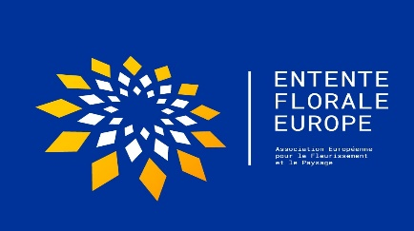

Entente Florale Europe – Green Space Award (WUP Endorsement)

The Green Space Award – endorsed by World Urban Parks - was introduced into the Entente Florale (EFE) Competition in 2022.

The competition has ten criteria, the fifth of which is entitled ‘Green Spaces’. Adjudicators allocate marks to each criterion to a maximum of 10 points. The participant city, town or village which has the highest total mark for the ‘Green Spaces category’ will be awarded the prize.

There is no requirement for participants to indicate their interest in being considered in advance of the assessment. All participants are automatically eligible.

